**Roll No :- 04**

**Name :- Rohan Vikas Badhe**

**Practical No :- 08**

**Practical Name :- Use git merge to merge you changes to the primary branch.**

comp@comp214 MINGW32 ~/KBCNMU (branch2)

$ git merge master branch2

Already up to date.

comp@comp214 MINGW32 ~/KBCNMU (branch2)

$ git branch --list

* branch2

master

comp@comp214 MINGW32 ~/KBCNMU (branch2)

$ git checkout master

Switched to branch 'master'

Your branch is up to date with 'origin/master'.

comp@comp214 MINGW32 ~/KBCNMU (master)

$ git checkout branch2

Switched to branch 'branch2'

Your branch is up to date with 'origin/branch2'.

comp@comp214 MINGW32 ~/KBCNMU (branch2)

$ git pull https://github.com/Utkarsha0510/KBCNMU.git

remote: Enumerating objects: 1, done.

remote: Counting objects: 100% (1/1), done.

remote: Total 1 (delta 0), reused 0 (delta 0), pack-reused 0

Unpacking objects: 100% (1/1), 628 bytes | 18.00 KiB/s, done.

From https://github.com/Utkarsha0510/KBCNMU

* branch HEAD -> FETCH_HEAD

Updating 9f81095..a4f7896

Fast-forward

**Before Merge to local repository:**

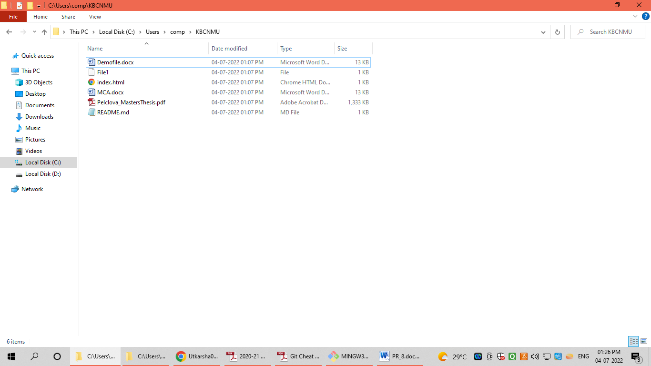

**After Merge to local repository:**

